Shabbos Stories for
Yom tov shavuos 5781
Volume 13, Issue 38 6-7 Sivan/May 17-18, 2021
Printed L’illuy nishmas Nechama bas R’ Noach, a”h

For a free subscription, please forward your request to keren18@juno.com
Past stories can be found on the website ShabbosStories.com

Story #1172
A Shavuot Deposit
From the desk of Yerachmiel Tilles

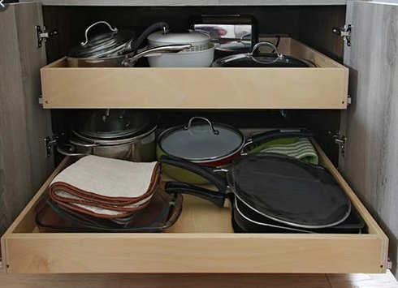

Sunset and the festival of Shavuot were fast approaching. The Jewish merchant hurried frantically towards the Beit Midrash Study Hall in Lishinov, Austria. He was in the midst of a journey to purchase merchandise and pursue investments, and had detoured to spend Shavuot with his rebbe.
Now though, while it was still permissible to carry money, he had to quickly find a secure place to hide the thick wallet of currency that was bulging in his jacket pocket. Yet hours had already passed in an unsuccessful search.
In desperation he decided to reconsider his first idea, which he had originally rejected as being too impudent. He would ask the rebbe himself to keep the money in a safe place until the 48 hours of the festival ended. Who could possibly be more reliable than the rebbe!

With Fear and Trembling He Approached the Rebbe
He ran into the Beit Midrash, took a few deep breaths, gathered his courage, and in fear and trembling, respectfully requested from the rebbe that he allow him to deposit his wallet with the Rebbe for safe-keeping over the holiday.
The Rebbe, Rabbi Mordechai of Neshkiz, presented his chasid a big smile and said that he is happy to oblige him. He took the money, and with the owner watching him closely, he stuck the wallet deep within a large kitchen cabinet filled with pots and dishes, placing it inside a large bowl, and then inserting another bowl of the same size on top of it.
“Now you don’t have to worry anymore,” he addressed the merchant; “your money is hidden securely with us. So, go right away to the mikveh and prepare yourself for the holy occasion.”
The chasid felt as if a great load had been lifted from his shoulders, he was so relieved. He thanked the rebbe and parted from him with a light heart.
Before sunset, he joined the crowd of chasidim that packed the Rebbe’s synagogue. He found a place to sit between two friends, opened a book of Torah thought and began to study intently, completely detached from all thought of the work week that had passed, and even of the week to come two days later.
The atmosphere of festive holiness was palpable. The Evening Prayer for Festivals exalted the spirits of all present even higher, an exultation that continued through the holiday meal and reached its apex at the Rebbe’s tish (open table), where a large crowd of chasidim gathered after concluding their own meals.

A Flow of Inspiring Words
A flow of inspiring words from the Rebbe initiated preparation for the receiving of the Torah anew the following morning. Throughout the night, the chasidim read the traditional long passages of Torah in the Tikun Layil Shavuot. As soon as the sky began to brighten, the appropriate Morning Blessings were recited, and they delved deeply and enthusiastically into Torah study in preparation for the festive morning prayers.
After the first long section that concluded with the singing of the Hallel prayer, the Rebbe returned to his room to prepare himself for the recitation of the Akdamot [a prayer unique to Shavuot day] [1] immediately prior to taking out the Torah scroll from the Holy Ark.
Some of the chasidim, knowing it would be a while until the Rebbe returned and feeling weak from the all-night vigil, darted into the Rebbe’s house to nibble a bit of pastry in order to strengthen themselves for the major part of the Shavuot morning service. They returned quickly to the synagogue and joined the congregation in anticipation of the Rebbe’s return.

A Fiery Demeanor but a Sweet Voice
At last, the Rebbe entered and strode up to the table in the middle of the shul upon which the Torah scroll would be rolled open and read. His demeanor was fiery, but his voice was sweet as he began to chant the Akdamot and pour out his soul to the Creator of all. He himself read aloud from the open scroll, and when he started the portion of the Ten Commandments, every one present felt as if they were assembled at the foot of Mount Sinai.
Evening and morning, night and day. The 48 plus hours passed in a rarified spiritual atmosphere, with total detachment from the weekday world. The second day came to a close, darkness settled, and the large braided candle was lit for the concluding Havdala ceremony.
Afterwards, it was only with difficulty that the chasidim were able to depart from the Rebbe’s court and his presence.
Also the merchant chasid felt it difficult to descend from the spiritual heights he had crested and turn to the business affairs that awaited him. Still full of emotion, he entered the Rebbe’s home to request the return of his money.
The Rebbe hurried to the hiding place inside the kitchen cabinet and moved aside the upper bowl that concealed the wallet. It was not there!
The rebbe was shocked momentarily, but then he figured that perhaps it had fallen from the bowl deeper inside the cabinet. He felt along the sides and on the lower shelf, but there was no trace of it, not a single bill.

The Entire Household was Hastily Summoned
He hastily summoned his entire household to help in the hunt. The traumatized merchant stood frozen in place, his face white as frost.
All the frantic searching produced zero results. The rebbe approached the stunned merchant and did his best to calm him. “Don’t worry. I’ll give you now all the money I have in the house, every last ruble, and the rest I will with G-d’s help pay you back in installments.
“Heaven forbid that the Rebbe’s savings should be drained on my account,” the chasid cried out. I won’t take even a kopek [2] from the Rebbe.â€
The matter of the theft disturbed the Neshkizer greatly. How much suffering he had caused his devoted follower! He decided that emergency measures were called for.
During this time period, the great tzadik (holy man), one of the three main senior disciples of the Baal Shem Tov, Rabbi Pinchas of Koritz, was living in the nearby town of Brody. Rabbi Mordechai of Neshkiz decided he would go to Brody and ask the tzadik for his advice and blessing, even though he had never visited him even once before.

Waiting and Hoping for a Positive Development
He set out that same day. The merchant meanwhile was still in Lishinov, waiting and hoping for a positive development.
In Brody, R. Mordechai headed directly to the shul-study hall of R. Pinchas. Before entering he saw in the courtyard a middle-aged Jew pacing back and forth while engrossed in reading Tehilim (Book of Psalms). He walked towards him and said, ‘Excuse me. Please can you tell me when it is possible to speak with the Rebbe?’
The man ignored him. He didn’t even break stride or pause his recitation. Maybe I’m not close enough, or maybe I didn’t speak loud enough, wondered R. Mordechai.
He stepped closer and raised his voice considerably. No response. “Could he be deaf,” he wondered even more, or is he simply rude? He decided to try one more time, more loudly and a bit sharper.
What is the explanation of such behavior? Is it really impossible or so difficult to tell a guest in which hours the Rebbe receives people?
The man stopped in mid-step and ceased his Psalm-saying. He turned to look directly in the eyes of R. Mordechai and said, “And what is the explanation of the ineptness of a younger man that he does not know how to properly secure the money another person entrusted to him for safekeeping?”
R. Mordechai instantly realized that this Jew must be R. Pinchas himself. He apologized for his brusque speech and reported to him all the details of the unfortunate mishap with the deposit.

Advice from Reb Pinchas
“Listen to me,” R. Pinchas said in a tone of assurance. “Tomorrow morning, make sure to go up to lead the prayers. When you reach The Song of [the Egyptians drowning in] the Sea, enunciate extra loudly and clearly the verse, “Amar oyeiv: erdof; aseeg; achaleik shalal” -- ˜Said the [Egyptian] enemy: I will pursue [the Jews]; I will overtake, I will divide the plunder”[Ex. 15:9].
“At the moment you are saying these six words, count the men that are praying alongside the north wall of the shul, one person per word. The person who corresponds to the word ‘shalal/plunder,’ you can be certain this is the thief!”
R. Mordechai did exactly as R. Pinchas instructed. When he said shalal he stared intently at the sixth man from the right along the north wall of the shul. Instantly the man’s face turned as white as his shirt and he fainted. The shul was in an uproar until finally the man opened his eyes and stood up, and then returned to his prayerbook.

A Broken Confession by the Thief
After the prayers, the man hurried to see the Rebbe privately, and in a broken voice confessed that he was indeed the thief. He told that he was one of those who had gone into the Rebbe’s house on Shavuot morning to taste something, and had noticed the wallet in the cabinet. A strong desire for the money overcame him, so he snuck it all into one of his pockets.
“Rebbe! Please!” he exclaimed and burst into tears. “Instruct me how to do teshuvah (repentance).
Only after the man returned the sum in its entirety did the Rebbe prescribe for him a path to rectification. The man fulfilled meticulously every detail in the rebbe’s directive. With the passage of time, he became a well-respected chasid of Rabbi Mordechai of Neshkiz.
~~~~~~~~~~~~~~~

Source: Translated and adapted by Yerachmiel Tilles from the Hebrew weekly Sichat HaShavua, #1586 (based on ‘Reshpei Aish’).
Connections (2):1- The festival of SHAVUOT. 2- The 8th of the 10 Commandments: “Do Not Steal”
Biographical notes (in order of appearance): R. Mordechai of Neshkiz [1740 - 8 Nissan 1800] was descended from the Maharal of Prague and Don Yitzchak Abarbanel. He was a disciple of R. Yechiel Michel of Zlotchov. The ill and the unfortunate came to visit him from long distances. It is recorded that he never uttered a negative word about another person. He actively supported settlement in Eretz Yisrael. He was succeeded by his son, R. Yitzchak of Neshchiz. His sayings were collected in Rishpei Eish.
Rabbi Pinchas of Koretz (ben R. Avraham Abba Shapiro) [10 Elul (1726 - Sept. 1791 C.E.] was considered to be one of the two most pre-eminent followers of Chassidism's founder, the Baal Shem Tov (along with his successor, the Maggid of Mezritch). His teachings appear in

[1] Recited in most Ashkenazic and Chasidic congregations. Most Sephardic congregations employ a different beautiful prayer, known as Azharot.
[2] 1oo kopeks = 1 ruble

Reprinted from the Shavuos 5780 email of KabbalaOnline.org, a project of Ascent of Safed.

The Essence of Shavous
By Rabbi Tuvia Bolton

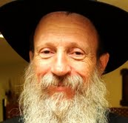

This coming Sunday night we will celebrate Shavuot when the Creator of the Universe gave us the Torah 3,333 years ago.
Shavuos is the most important Jewish holiday; without the Torah there would be no Judaism and no Jews. But even more, it is the most important date in history; Rashi (Braishis 1:31) informs us that if the Jews hadn’t received the Torah there would be no world!
But seemingly not much happened on that day.
The Jews did not really receive the Torah or even the Tablets on that date but months later (because Moses broke them). On Shavuot the Jews merely HEARD the Ten Commandments.
One would think that after suffering 210 years in slavery, experiencing a series of mind-boggling miracles like leaving Egypt, splitting of the sea and more they would receive more than just hearing a few simple statements like 'I am G-d," and 'Don't Kill" So what is so special about this holiday?
To answer this here are two stories:
The first I heard years ago from a very unique and genuine Chassid called Rabbi Mendel Futerfass.
He lived in Russia under the reign of Communism, the government had closed all Jewish printing houses and holy books were a rare commodity. Once he saw another Chassid coming out of the Shamos bin (usually a small side room in the shul where scraps of holy books are kept) with a handful of torn pages from holy books.
“What are you doing” asked Rav Mendel.
“I can't find any Torah books" was the reply. "So once in a while I go in here, take a few of these loose pages home, sew them together and make a book to learn from.”

A Book of Unrelated Pages
But what kind of book is that?” Rav Mendel asked, “I mean, there will be no beginning and no end, just unrelated pages! How can you read a book like that?”
“Well,” his friend calmly replied, “I look at it this way. In the Torah there are three things; there is the commandment of learning Torah. Then there is the commandment of understanding Torah but then there is also the Holiness of the Torah. The first two depend on understanding, but the last, the Holiness of the Torah, is the letters of the Torah. Every letter is holy. And that’s what my book will be about!”
Second story:
I used to put tefillin on Jews in the central bus station of Tel Aviv. (For those unfamiliar with Chabad tefillin campaign it goes like this: You take at least one pair of good Tefillin, one folding table, situate yourself in some busy place and ask Jews if they want to put on Tefillin)
So one Friday I'm standing before my table and this non-religious-looking soldier walks by. So I asked him if he would like to put on Tefillin. Suddenly he stopped turns to me, face red and contorted with anger, and begins shouting. “Tefillin? Because of you maniacs with your Tefillin I sat in Military prison for two months! So leave me alone!!!”

Carefully Questioning Him from a Distance
He didn't move on so I asked him what he meant, while keeping my distance, because he was pretty mad.
“I'll tell you what I mean!!" He hissed. "Four months ago I decided go AWOL for a weekend from army. I snuck out of the base, caught a bus to Tel Aviv with a whole weekend of fun planned. But as I got off the bus one of you guys asked me to put on Tefillin at his Tefillin stand.”
He paused for a second. He was standing a bit too close for comfort, then took a few quick deep breaths and continued.
“So, I put them on and WHILE I was putting on the Tefillin the Military police saw me, arrested me and I HAD TO SIT IN JAIL FOR TWO MONTHS BECAUSE OF YOU!!!
I saw that he was really angry, and he just stood there. It was hard to tell what he was going to do so I looked him back in the eye and as calmly as possible asked him: “So? Nu? Want to put on Tefillin?”
He looked at me, looked at the Tefillin, and looked back at me one more time and without changing his expression, took one step back, rolled up his sleeve and said “Lama LO?” (lit. Why not?) And he put on Tefillin.

The Answer to Question of What G-d Gave Us
This answers our question about what G-d gave us on Shavuos,
On Shavuos G-d gave Himself.
This is what the Chassid in our first story found in his 'Torah scrap book' and what made the soldier in the second story put on Tefillin.
The first word of the Ten Commandments sums it all up: “ANOCHI.”.
G-d has a lot of names and according to Kaballa each name corresponds to a different facet of His infinite personality. But the name ANOCHI is not one of them. It means 'I' and refers to essence of G-d himself; above all names. And this is what the Jews received at Mount Sinai. Each and every Jew for all time heard individually; "I am YOUR (singular) G-d.”
King Solomon in his Song of Songs(3:11) compares it to a wedding day between G-d and the Jewish people. (See Mishna Taanit 4:5).
The experience was so unique and eternal that until this very day no one can even begin to understand it. No religion, (even those that claim to replace Judaism) has ever even invented such a 'G-d' who would reveal Himself to an entire nation of millions of ordinary people.

The Closeness of G-d to Us Today!
What this means today is that when a Jew, any Jew, learns Torah, (especially if learning aloud) they can feel a bit of what happened at Sinai 3333 years ago. The feeling that G-d is closer to us than we are to our own selves!
It’s called “The G-dly Soul.” (Tanya chap. 2)
This Torah feeling is what made the Holy Temple 'Holy' (The Ten Commandments were kept in the Holy of Holies). It is what draws people to the Western Wall today and what has been keeping Judaism (and Jews) alive and vibrant through thousands of years of oppression.
Therefore, the Torah is called Aitz Chaim the "Tree of Life" (Prov.3:18). And in our prayers; “Chayai OLOM” (Eternal life) and “Torat Chaim) (The Law of Life) because It gives us life and teaches us what life really is (Unlike various other bibles that are products of life).
Even more; it give eternal life; The Talmud (Shabbat 88b) tells us that at Sinai death actually ceased; we received the Dew (Tal) of the Torah that will enliven the dead completely above any human understanding.
That is what we are celebrating on Shavuot.
Reprinted from the Shavuos 5780 email of Yeshiva

United We Camp
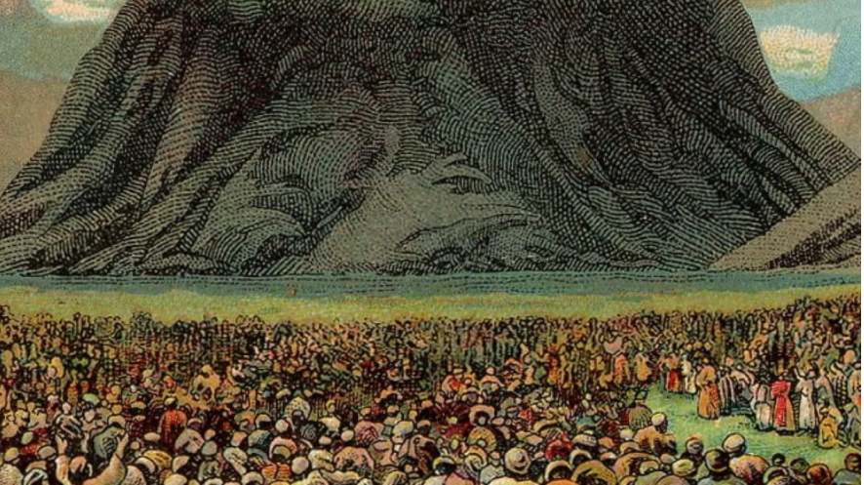 A 1907 postcard depicts the Israelites gathered in awe at the foot of Mount Sinai for the revelation of the Ten Commandments. (Reprinted from the Jewish News of Northern California.)

When B’nei Yisrael they left Egypt and journeyed to the Sinai desert, it says: “vayahanu bamidbar, vayihan sham yisrael neged hahar — and they camped in the dessert, and he camped there opposite the mountain.” First the passuk writes that “they camped” in plural. But when it writes that B’nei Yisrael camped at Har Sinai, it switches to singular.
Rashi comments on the usage of the singular form: “k’ish ehad, b’lev ehad — Like one man, with one heart.” This is because at Har Sinai, B’nei Yisrael were like one person, with one heart. That unity gave us the merit to receive the Torah!

There is nothing greater in Hashem’s eyes than seeing B’nei Yisrael unified in harmony as one close nation, just as a father loves seeing his children close to one another, getting along and unified as one.
May we all continue to be special in Hashem’s eyes and in the eyes of the Nations so as to make a Kiddush Hashem, as we celebrate the acceptance of the greatest gift any nation could ever receive, our holy Torah. May we also continue be as one nation, and always be concerned for the welfare of our fellow Jews, and make sacrifices for those close to us, as the passuk says: “ve’ahavta lere’aha kamoha — Love your friend as you love yourself!”

Reprinted from the Shavuot 5781 email of Jack E. Rahmey based on the Torah teachings of Rabbi Amram Sananes.

19th Century Romanian Silver Torah Shield

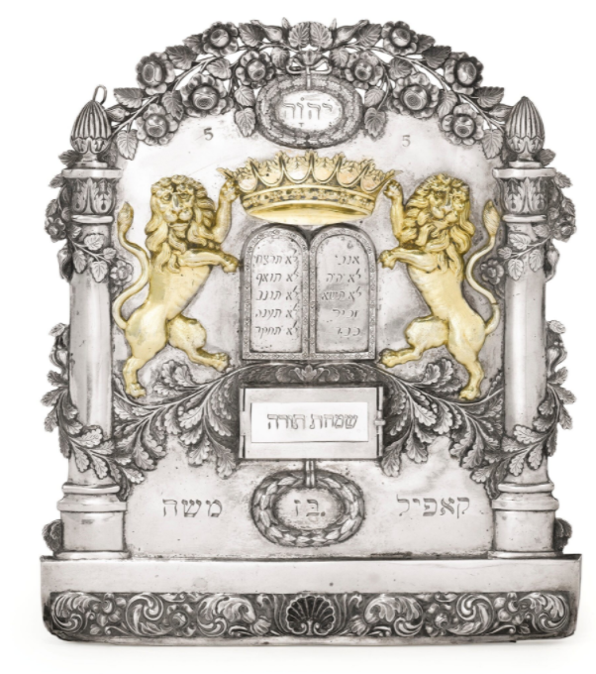
This attractive 19th Century Torah Shield sold in the 2012 Sotheby’s Important Judaica auction for $15,000.

